Snell’s Law Song
Words by Marian McKenzie & Walter Smith 12-8-02
Tune: Sweet Betsy from Pike (traditional)
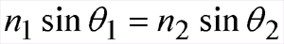

C C G7 C

Come listen and learn, I’ve a story I tell,

C Am G G7
I sing of the genius of Willebrord Snell

C Em F C

A mathematician who lived long ago

C C G7 C

In the Netherlands where the Rhine river does flow.

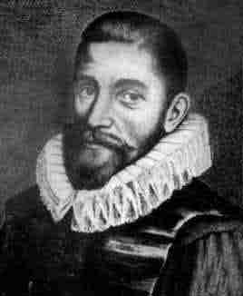
Willebrord van Roijen Snell
1580-1626
(Note that the first name is actually pronounced “Villbrort”, but in the song is pronounced “Vill-e-brort”.)

C C G7 C

He set for his mind occupations of worth,

C Am G G7
Improved navigation and measured the Earth!

C Em F C

He gave us the sine law, that wonderful guy,

C C G7 C

And he made more precise calculation of pi!

C F (or C) G (or G7) Am (or C)

Singin’ n1 sine theta-sub-1, hey, hey, hey,

C F (or C) G (or G7) C
Equals n2 sine theta-sub-2, hip hooray!

C C G7 C

His greatest feat came in Sixteen Twenty-one,

C Am G G7
When optics as science was really begun!

C Em F C

While flashes of lightning illumined his page,

C C G7 C

He wrote down Snell’s law, his great gift to the age!

C C G7 C

So if you wear glasses or like to fry ants,

C Am G G7
Be grateful your lenses were not made by chance!

C Em F C

Astronomers hail him with each new-found star!

C C G7 C

Microscopists toast him from each sleazy bar!

C F (or C) G (or G7) Am (or C)

Singin’ n1 sine theta-sub-1, hey, hey, hey,

C F (or C) G (or G7) C
Equals n2 sine theta-sub-2, hip hooray!

C C G7 C

Now some credit Harriot, others Descartes,

C Am G G7
Both studied refraction, and both were real smart.

C Em F C

But we prefer Willebrord van Roijen Snell --

C C G7 C

He laid down the law, and he did it darn well!

C F (or C) G (or G7) Am (or C)

Singin’ n1 sine theta-sub-1, hey, hey, hey,

C F (or C) G (or G7) C
Equals n2 sine theta-sub-2, hip hooray!

© 2002 Marian B. McKenzie and Walter Fox Smith

