Lost in Hilbert Space
Walter Smith, 10-8-01 (Chords by Marian McKenzie)
(Tune: Theme from “Lost in Space”, third season)
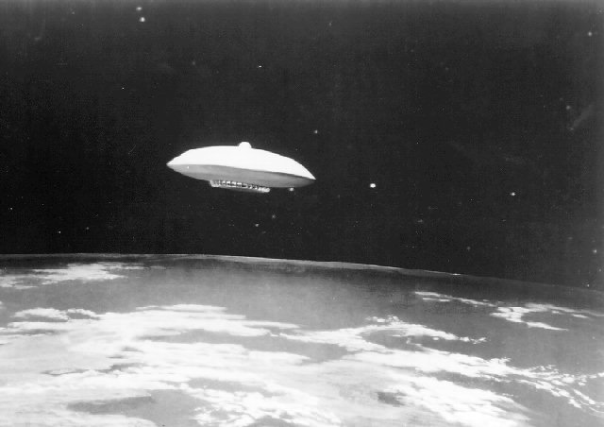
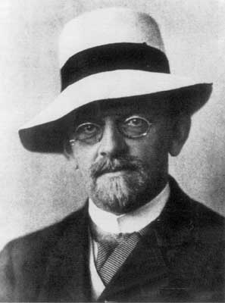
David Hilbert 1862-1943
E

Let’s take a rocket ship

E

And blast off upon a trip,

D C B

A trip not among the stars, but in a stranger place!

E
A realm where each point means more

E

Than it ever meant before,

D C B

A realm with the oddly-thrilling name, Hilbert space!

E
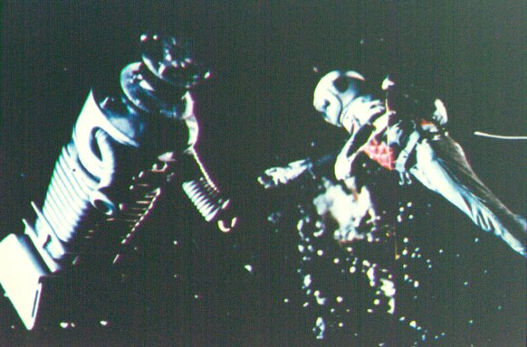

Oh --- Holy Cow! ⎫
⏐
A E ⏐

Look out the windshield now! ⏐
⏐
A C ⎬ (bridge)

The functions flying by! ⏐
⏐
C B ⏐

Exponentials fill the sky! ⎭

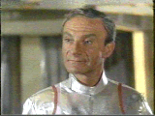
Dr. Smith, from “Lost in Space”, as portrayed by Johnathan Harris
E

Look how the basis vectors

E

Reach out to all the sectors!

D C B

This is the great achievement of the human race!
E

It’s called Hilbert space!
© 2001 Walter Fox Smith

