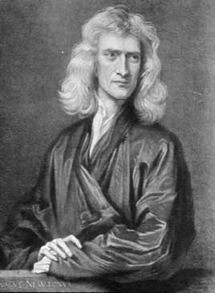
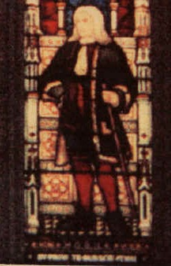

Isaac Newton (in 1689)
Robert Hooke (1635-1703)
1676:F = -kx 1666: F = ma
-kx = ma

The Hooke and Newton Song:

Optional Intro:
C C F C F C G7 C

Doo Doo, Dooo Doo, Doo Doodle-oo ↑Dooo Doo

C C G7 C C G C
Doo Doo, ↑Dooo Doo, Doo Doodle-oo Doo.

Chorus:

C C F G

Hooke on the left, Newton on the right

F C G C

Gives you an equation that’s really outta sight!

C C F G
Short and sweet, full of hidden delight –

F C G G
And the spring goes up and down, and down

C G C
And the spring goes up and down.

C C F G

Hooke and Newton were rivals in their day,

F C G C

But partners for eternity is how they’ll have to stay!

C C F G
Minus kx equals ma,

F C G G
And the spring goes up and down, and down

C G C
And the spring goes up and down.

Repeat Chorus twice.

Words, Chords, & Intro. by Walter Smith 7-01
Tune from the PBS program “Dragontales”

